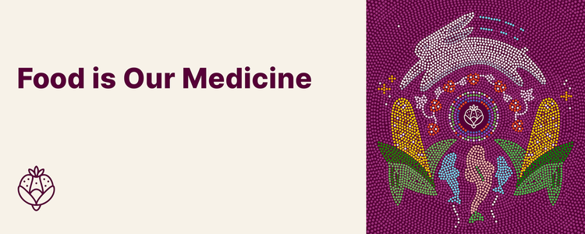
Instructions
- We encourage you to cross-reference the notes you took in your journal while reading through the introduction and completing each season to complete the worksheets.
- Create a Food is Our Medicine folder in your files where you can save this worksheet booklet and the PDF modules for each of the five modules.
- Once you complete all five seasons and worksheets, you can upload them to our platform here. Be sure to follow the instructions to receive your certificate.
- Your worksheets will not be shared with anyone outside of Nourish.
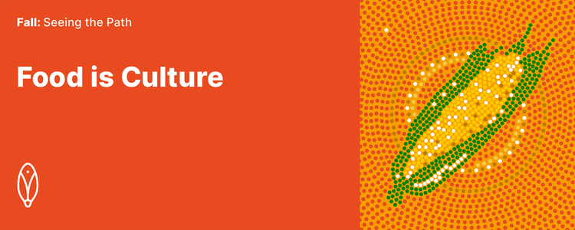
Introduction & Fall
- Why are you motivated to complete this learning journey? Consider:
- Why did you decide to go on this learning journey?
- What do you think you might gain by completing this learning journey?
- What hopes and fears come up as you think about the learning (and unlearning) that might be ahead?
- By when do you commit to completing the four seasons of this learning journey?
- Have you invited any colleagues to accompany you with a shared completion goal?

Start typing...
Teaching 1
Recall Etuaptmumk, the concept of “two-eyed seeing” described by Mi'kmaq Elder Albert Marshall, and reflect on which lens is dominant for you personally and at your organization. Consider:
- How do the spaces you move through (your community, your workplace, your home) shape, change, or reinforce the lens you see through?
- What lens(es) does your workplace privilege or reward you for using?
- In the video, Elder Albert Marshall asks how we can weave back and forth between these two ways of knowing. Are you ready and willing to “put on another [or different] lens”?
- What do you stand to lose by trying on a different lens? What emotions, thoughts, or sensations come up?
- What do you think you might gain from seeing through a different lens?

Start typing...

Teaching 2
What traditional territory do you live and work on? How do you relate to this land? What questions do you have about the Indigenous peoples from your community?
Try to come up with 2–3 specific questions that you can hold through this learning journey.

Start typing...

Teaching 3
What do you take away from the stories about Joyce Echaquan and Brian Sinclair, and the stories shared in the In Plain Sight report? Consider:
- What emotions, feelings, thoughts, or questions come up as you reflect on these stories?
- Have you witnessed systemic racism in your workplace? How does it show up? What assumptions or biases might be behind it?

Start typing...

Teaching 4
How do the histories of Canada described in Teaching 4 interact with your worldview of Canada? Consider:
- What strikes you about these pieces of Canada’s history? What, if anything, had you learned about them before?
- How might Canada’s colonial history influence the present-day relationships of patients, residents, and communities with food?

Start typing...

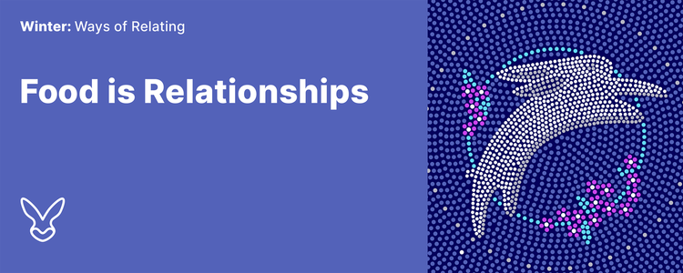
Teaching 5
Reflect on how Winona LaDuke and Elder Ralph Philips speak about the relationality of food. Consider:
- How do their perspectives of food—as relatives and as gifts—compare with your perspectives of food?
- In what ways is salmon more than food to the members of the Xat’sull Nation?
- What would the food served in your local hospital say if it could speak? What stories would it share from its journey to a patient’s plate?

Start typing...

Teaching 6
Reflect on the relationship between race, racism, and the determinants of health. Consider:
- What is the difference between “race” and “racism” as a determinant of health?
- What social determinants of health influence your personal wellbeing?
- What theories have you heard for increased rates of chronic disease among Indigenous peoples? What do you think about these theories now? What questions do you have?

Start typing...

Teaching 7
Reflect on the work of the Truth and Reconciliation Commission of Canada (TRC) as it relates to health care. Consider:
- What did you know about the work of the Truth and Reconciliation Commission before beginning this learning journey?
- What are your thoughts on the health-related Calls to Action (18–24)?
- What changes (if any) have you seen in your workplace since the TRC report was published in 2015?
- What next steps could you take to advance the Calls to Action in your personal life? What about in your professional life?

Start typing...

Teaching 8
Reflect on how your values and principles as a health care professional can foster cultural safety. Consider:
- Which values and principles expressed by the Royal College of Physicians and Surgeons resonate with you? Which, if any, surprise you? How do the values and principles in your practice or organization compare?
- How might you cultivate cultural mindfulness in your work?

Start typing...

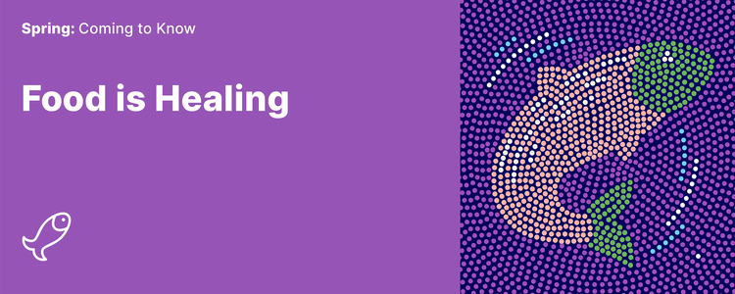
Teaching 9
Reflect on what constitutes a “healthy diet” and on the benefits of Indigenous foods and perspectives for the overall health of Indigenous peoples. Consider:
- Throughout your life, what messages have you heard about a “healthy diet”? Whose perspective(s) are these messages from? How do they compare to the perspectives shared in this teaching?
- What opportunities do you see to leverage Indigenous foods and perspectives for better overall health of Indigenous peoples?

Start typing...
Teaching 10
Reflect on how traditional foods promote health and how eating them fosters culture, as illustrated by Jared Qwustenuxun Williams’s diagram. Consider:
- What did you learn in this teaching about the connection between the mind, body, spirit, and emotions?
- How would you describe Indigenous food systems to someone who is not familiar with what you have learned so far on this learning journey?
- What does “food is medicine” mean to you now?

Start typing...

Teaching 11
Reflect on foods and foodways, both new and familiar:
- This teaching has shared a few specific foods and foodways from across Turtle Island. Are any of these traditional to the region where you live and work?
- Think about your own culture, family, and home. What foods are traditional to you? What stories are connected to these foods and the way that you obtain, prepare, and share them?

Start typing...

Teaching 12
Given the impacts of COVID-19 on food security and sovereignty, reflect on the benefits of a self-determined approach to food systems planning for Indigenous peoples and communities. Consider:
- What solution to support food access issues did the government implement that undermined Indigenous peoples in addressing food insecurity during the pandemic?
- How did COVID-19 exacerbate food insecurity?
- What activities, practices, and foodways strengthen food security?
- How is it helpful to take a long view in food systems planning?

Start typing...

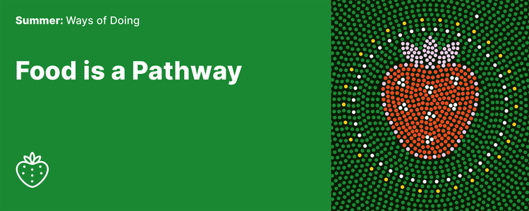

Teaching 13
Reflect on the barriers to serving traditional/country foods in health care settings. Consider:
- Which of the barriers identified by the Nourish TFP team have you experienced?
- How have you overcome, or tried to overcome, any barriers? What solutions, innovations, or compromises have you come up with?
- What has helped or hindered the process of serving traditional foods where you work?

Start typing...
Teaching 14
Many people are involved in establishing and running the traditional food programs shared in this teaching. Consider what this means for your setting and facility/organization:
- Which relationships with key stakeholders at your facility/organization are strong? Which do you need to strengthen? Which do you need to start building?
- What questions do you have for stakeholders involved in any of the traditional food programs shared in this teaching?

Start typing...

Teaching 15
This teaching shared tools from programs in Sioux Lookout, Thunder Bay, and Nunavut that you can adapt, build on, and be inspired by.
- In thinking about these programs, and the different approaches they take, what ideas come up for you for ways to start (or continue) this work in your context?
- What lessons can you apply in your work setting? Who and what can support you?

Start typing...

Teaching 16
Consider your situation and your path forward.
- How do you now define “the work”? How has your perception of the work grown or changed over the course of this learning journey?

Start typing...

- Revist the notes you jotted about themes related to traditional foods in health care (below). Which themes resonate most with you? Where do you see the most opportunity for growth and change in your work? Which themes feel more challenging?

  - Love and respect
  - Guidance
  - Myths and stereotypes
  - Access
  - Networks and partnerships
  - Legislation

Start typing...

Endings… and Beginnings
Reflect on how you will continue this journey, personally and/or professionally.
- What are your next steps?
- What do you want to learn more about?
- How do you plan to continue practising humility and self reflection?
- What would it look like for you to practice being an ally to Indigenous patients, community members, and colleagues, in the work of reconciliation?

Start typing...

